Anovelo da Imbonate. "JPGM MS 26 fol. 9 Detail, A Crowd of Lay Worshippers Giving Thanks to Saints Aimo and Vermondo," parchment, ink, about 1400 (Paul J. Getty Museum, Los Angeles). In Fashion in the Middle Ages, by Margaret Scott, page 34. Los Angeles: Getty Publications, 2011.
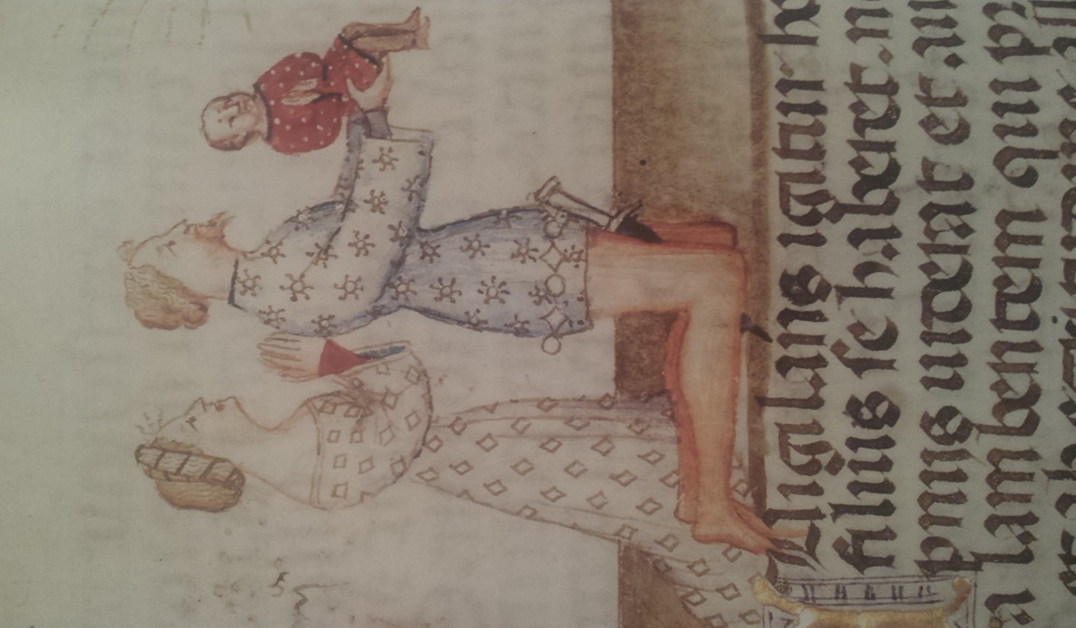
Anzio da Monza. "Ms. Ludwig VI 3. Fol. 16, Initial R: The Resurrection," parchment, late 1400s or early 1500s (Paul J. Getty Museum, Los Angeles). In Fashion in the Middle Ages, by Margaret Scott, page 101. Los Angeles: Getty Publications, 2011.
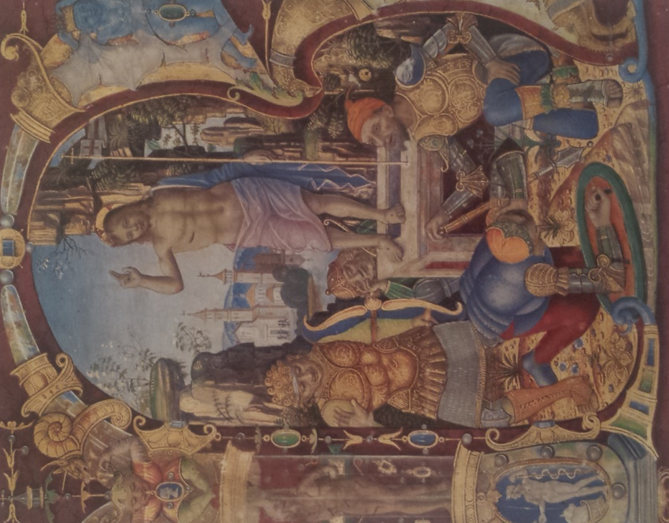
Harley 2895 f. 82v Detail, David and Goliath, gold leaf, penwork and parchment, late 12th century (British Library, London). http://www.bl.uk/catalogues/illuminatedmanuscripts/record.asp?MSID=8623.
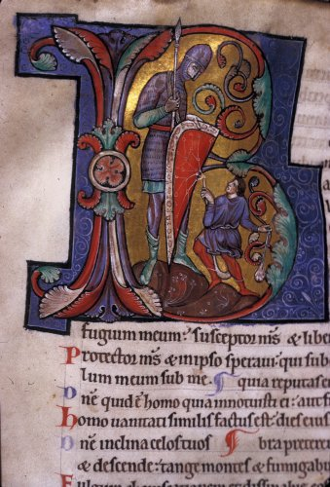
"Harley MS 4374 f. 88 Detail, The Siege of Capua," parchment, ink, about 1475 (British Library, London). In The Illuminated Manuscript, by Janet Blackhouse, page 69. Oxford: Phaidon Press, 1979.
"Hector and Tercian in Combat, fol. 39v, Hector Meets a Damsel in the Woods," parchment, ink, gold leaf (Paul J. Getty Museum, Los Angeles). In Imagining the Past in France: History in Manuscript Painting 1250-1500, by Elizabeth Morrison and Anne D. Hedeman, page 112. Los Angeles: Getty Publications, 2010.
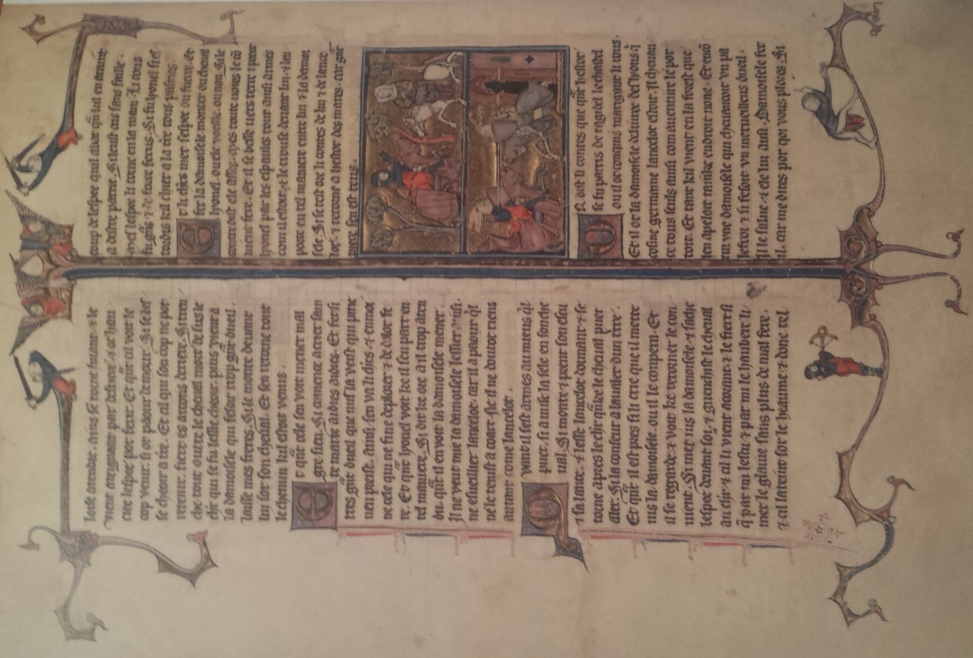
"Hector and Tercian in Combat, fol. 39v Detail, Hector Meets a Damsel in the Woods," parchment, ink, gold leaf (Paul J. Getty Museum, Los Angeles). In Imagining the Past in France: History in Manuscript Painting 1250-1500, by Elizabeth Morrison and Anne D. Hedeman, page 8. Los Angeles: Getty Publications, 2010.
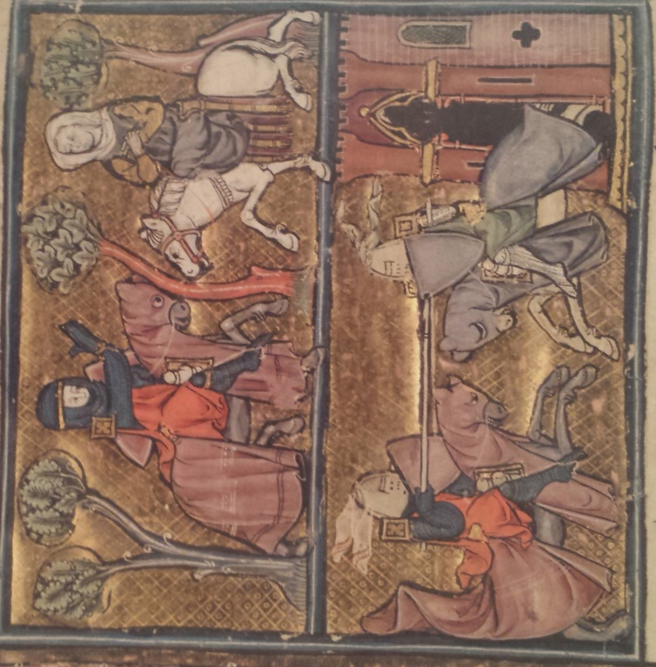
Morrison, Elizabeth and Anne D. Hedeman, Imagining the Past in France: History in Manuscript Painting 1250-1500. Los Angeles: Getty, 2010.
"MS 33733 f. 9, The Siege of Vienna," parchment, 1529. In The Illuminated Manuscript, by Janet Blackhouse, page 78. Oxford: Phaidon Press, 1979.
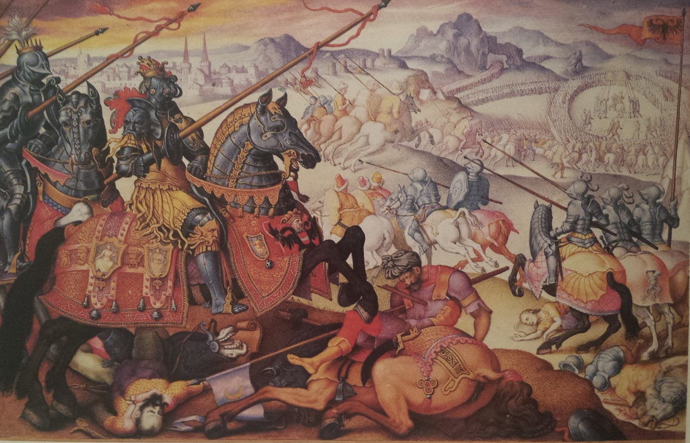
"Ms. M. 522, fol. 127v Detail, Initial A: Jews Honored by the Asians; the War Between Antiochus and Ptolemy in Josephus," parchment, ink, ca. 1280 (The Pierpont Morgan Library, New York). In Imagining the Past in France: History in Manuscript Painting 1250-1500, by Elizabeth Morrison and Anne D. Hedeman, page 12. Los Angeles: Getty Publications, 2010.
Santa Maria, Strela do Dia, by Makemi, 2014, Web.
"Scythian Women Besieging Their Enemies, The," parchment, ink, about 1286 (British Library, London). In The Illuminated Manuscript, by Janet Blackhouse, page 43. Oxford: Phaidon Press, 1979.
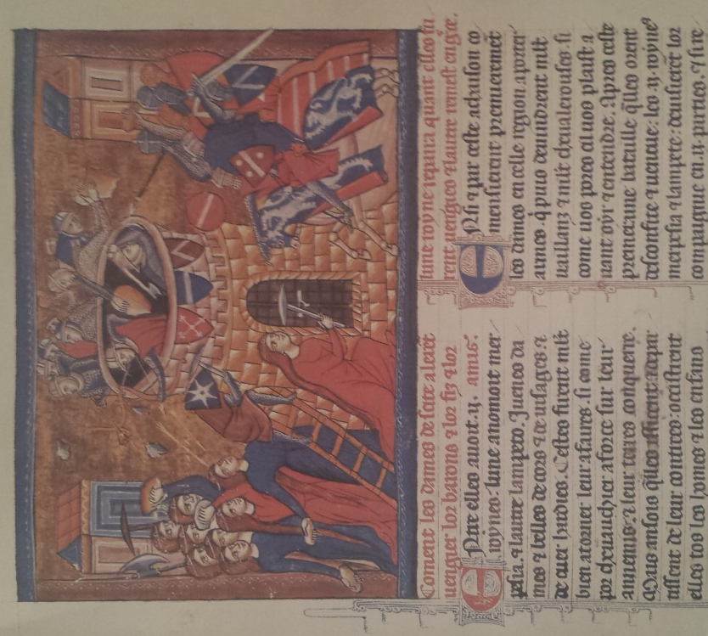
Spitz master. "Spitz Hours, The Way to Calvary," parchment, ink, and gold leaf, ca. 1420 (Paul J. Getty Museum, Los Angeles). In Fashion in the Middle Ages, by Margaret Scott, page 96. Los Angeles: Getty Publications, 2011.

